**Independent Practice**

Place your own buildings in the angled lots in the following map diagram.

Write sentences stating…

1. Whether the buildings are on “equal size lots” (congruent angles) or “different sized lots” (supplementary angles, adjacent angle, complementary angles)
2. Why you know the size of the lots using the angle relationships (vertical, linear pair, adjacent angles, same side interior, same side exterior, alternate interior, alternate exterior, corresponding)

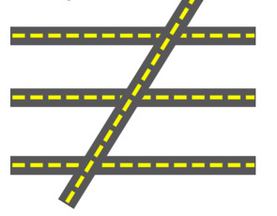

**Guided Practice**

*Make notes about the geometric relationships in the following map!*

